DSA Lab

Mr. ALEEM AHMAD

Bahria University

**Open Ended 2**

LAB Journal

Asim Ali (01-131232-015)

**Open Ended 2**

**Lab Task GitHub Link:**

[Link](https://github.com/iasimkhan2005/DSA/tree/main/OPEN%20ENDED%20II)

**OUTPUT:**

* **Menu**

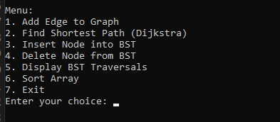

* **Add edge to Graph**

Start: 1, End: 2, Weight: 12

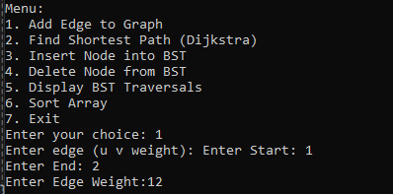

Start: 1, End: 2, Weight: 8

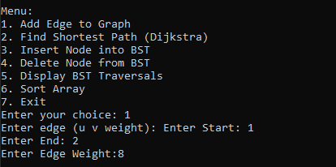

* **Shortest Path**

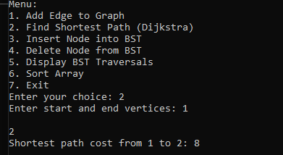

* **Insert Node to BST**

* **Display BST**

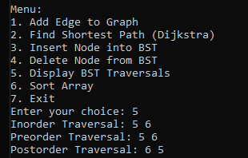

* **Sort Array**

